**HUBEI UNIVERSITY OF AUTOMOTIVE TECHNOLOGY**



**Python程序设计实训报告**

**课设题目： opencv图像处理程序设计**

**专 业： 计算机科学与技术（汽车智能化与信息化）**

**班 级: K计算机194**

**姓 名： 谭杨**

**成 绩：**

**完成日期: 2.23**

**指导教师: 吕成志**

目录

**Python程序设计实训报告** 1

**1、课程设计目的与任务** 3

1.1实验目的 3

1.2实验要求 3

1.3实验题目 3

**2、课程设计内容与要求** 3

opencv图像处理 3

**3、设计分析** 4

3.1程序简介 4

3.2功能实现 4

3.3整体思想 5

**4、总体设计** 6

4.1总体流程设计 6

4.2读取文件模块 6

4.3灰度化图片模块 7

4.4反色图片模块 8

4.5边缘提取模块 9

4.6缩放图片模块 10

4.7裁剪图片模块 11

5、运行结果与功能测试 12

6、源代码 15

7、总结 31

8、参考文献 31

## **1、课程设计目的与任务**

### 1.1实验目的

运用本学期课程的学习，使得学生能过熟练使用python开发环境，熟练运用python列表，元组，字典，集合等基本数据类型以及相关列表推导式，切片等特性来解决实际问题，熟练掌握python分支结构，循环结构，函数设计以及类的设计与使用，了解python程序的调试方法，熟练运用python编写面向对象程序，同时使我们自己了解那个领域的python扩展模块基本用法。

### 1.2实验要求

要求学生自己通过本学期对python的学习来来完成对特定程序的编写，并让其实现一定的功能，同时培养学生的分组合作的能力，培养学生自主学习的能力。

### 1.3实验题目

《Python语言设计实训》是一门实用性和实践性很强的课程，所以本课程的课程设计环节占有非常重要的地位。它是Python语言程序设计结束后的一门重要实践性课程，是为加强学生用程序设计的思想分析和解决问题的能力。我们选择的题目是opencv图像处理。处理信息的功能包括图像读取，图像显示，灰度变化，边缘提取，缩放，目标分割，裁剪等功能。

## **2、课程设计内容与要求**

### opencv图像处理

处理信息包括图像读取，图像显示，灰度变换，颜色变换，边缘提取、缩放、目标分割、裁剪等功能。

该系统需要能够提供下列功能：

（1）系统以菜单方式工作。（必做）

（2）读取文件夹图像（必做）。

（3）读取彩色图片（RGB格式）并转换成灰度图片（Gray格式）, 显示图片，保存到指定路径（必做）。

（4）读取彩色图片，对像素值进行反色处理（例如：（0，0，0）处理后变成（255，255，255））,显示图片，保存到指定路径（必做）。

（5）边缘提取，使用Canny算子提取图片边缘信息，显示图片，保存到指定路径（可选项）。

（6）图片大小变化，读取一张图片，缩小或者放大到指定尺寸，图片，保存到指定路径（必做）。

（7）目标分割，选择一张颜色对比明显的图片，设置合适的阈值，分割出图像中的特定颜色目标（可选项）。

（8）图片裁剪：指定像素大小裁剪出图片的一部分（必做）。

（9）使用pyqt实现功能界面（加分项）。

## **3、设计分析**

### 3.1程序简介

运用pycharm软件来当作python的开发环境。Opencv图像处理可以在pycharm安装opencv的库来进行操作。OpenCV-Python是一个Python绑定库，旨在解决计算机视觉问题。用pyqt来实现界面功能，PyQt6 是Digia的一套Qt6与python绑定的应用框架，PyQt6类分为很多模块，PyQt6类分为很多模块，但用来制作窗口界面的是QtGui 。QtGui包含了窗口系统、事件处理、2D图像、基本绘画、字体和 文字类。

用户界面(User Interface)是指对软件的人机交互、操作逻辑、界面美观的整体设计。好的UI设计不仅是让软件变得有个性有品味，还要让软件的操作变得舒适、简单、自由、充分体现软件的定位和特点。

用户界面（User Interface，简称 UI，亦称使用者界面[1]）是系统和用户之间进行交互和信息交换的媒介，它实现信息的内部形式与人类可以接受形式之间的转换。用户界面是介于用户与硬件而设计彼此之间交互沟通相关软件，目的在使得用户能够方便有效率地去操作硬件以达成双向之交互，完成所希望借助硬件完成之工作，用户界面定义广泛，包含了人机交互与图形用户接口，凡参与人类与机械的信息交流的领域都存在着用户界面。

### 3.2功能实现

系统各大模块如图2.2。

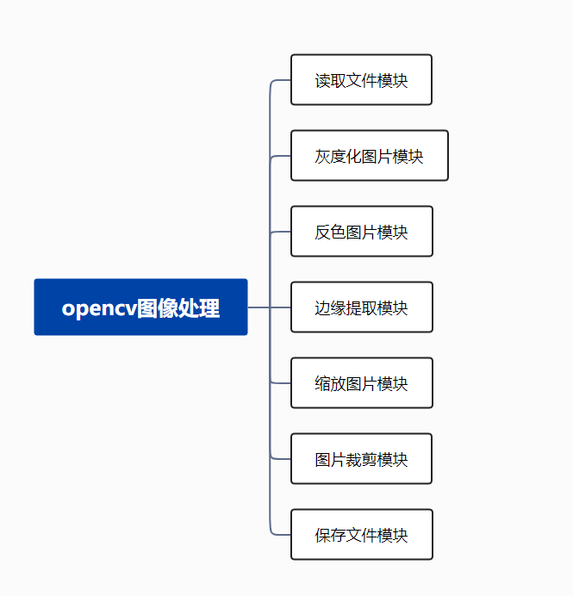

**图2.2系统功能结构图**

### 3.3整体思想

作为一个用户，呈现在用户面前的就是程序主界面。在程序主界面中，有各种功能可供用户选择。首先用户点击读取图片，从文件夹中读取一张.jpg.png格式的图片。然后再点击相应的模块按钮执行各种操作。

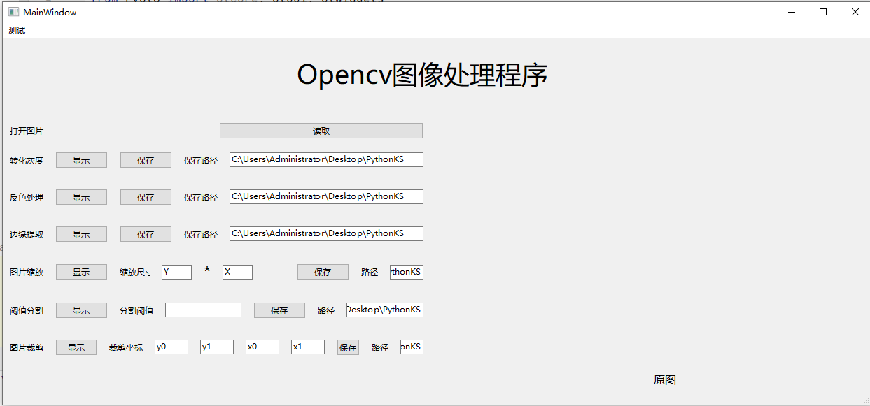

**图3.3.1用户图形界面**

## **4、总体设计**

### 4.1总体流程设计

程序总流程如图4.1。

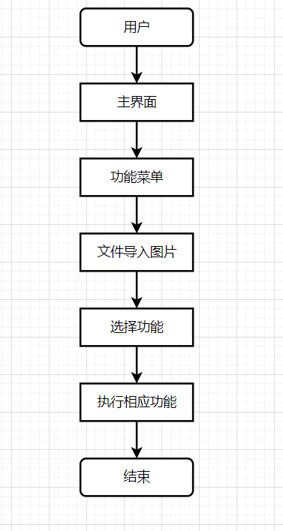

**图4.1主函数流程图**

### 4.2读取文件模块

录入职工信息模块流程如图4.2。

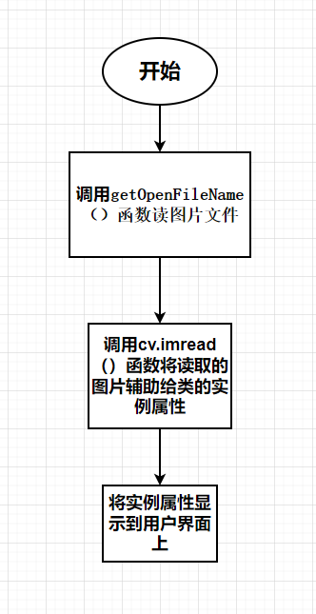

**图4.2录入职工信息流程图**

### 4.3灰度化图片模块

灰度化图片模块流程如图4.3。

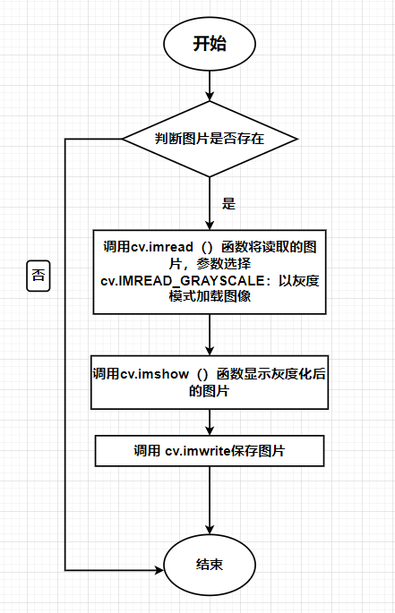

**图4.3灰度化图片流程图**

### 4.4反色图片模块

查找职工信息模块流程如图4.4。

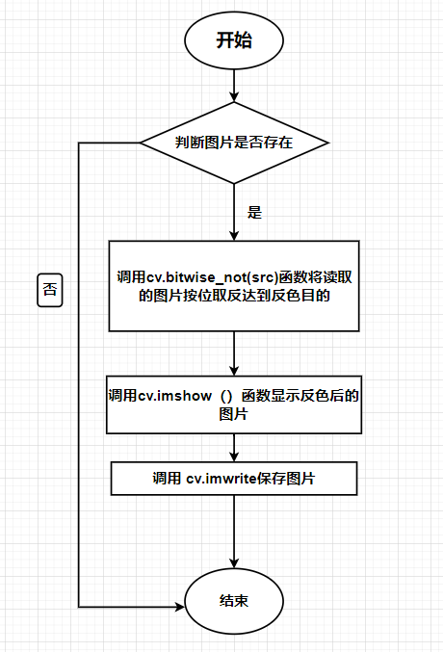

**图4.4查找职工信息流程图**

### 4.5边缘提取模块

边缘提取流程如图4.5。

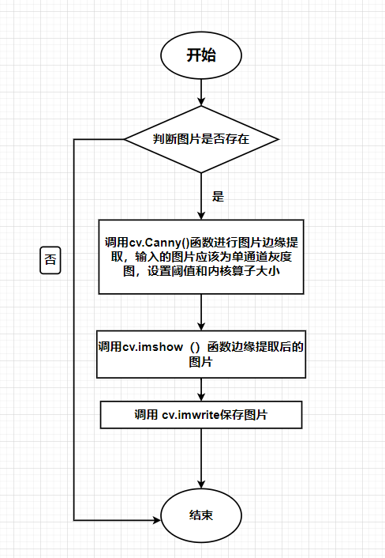

**图4.5边缘提取流程图**

### 4.6缩放图片模块

缩放图片模块流程如图4.6。

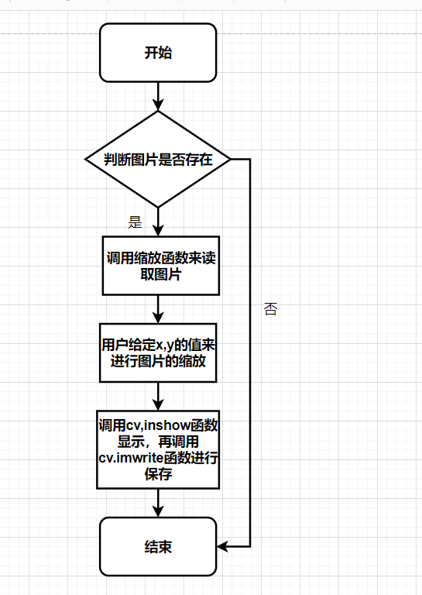

**图4.6缩放图片流程图**

### 4.7裁剪图片模块

裁剪图片模块流程如图4.7。

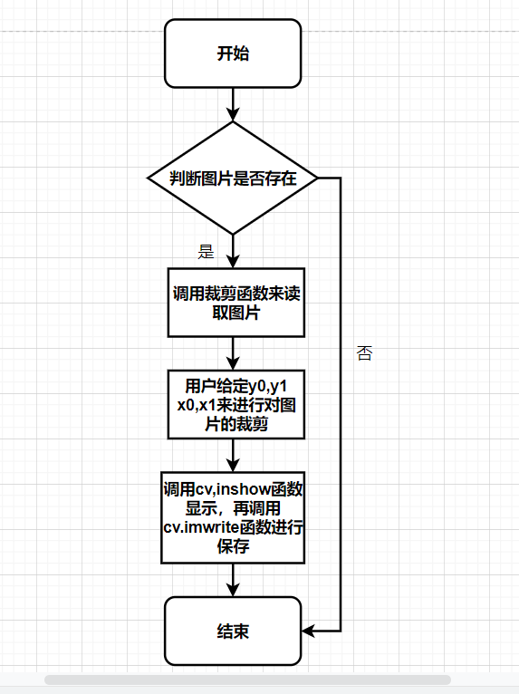

**图4.7裁剪图片流程图**

## 5、运行结果与功能测试

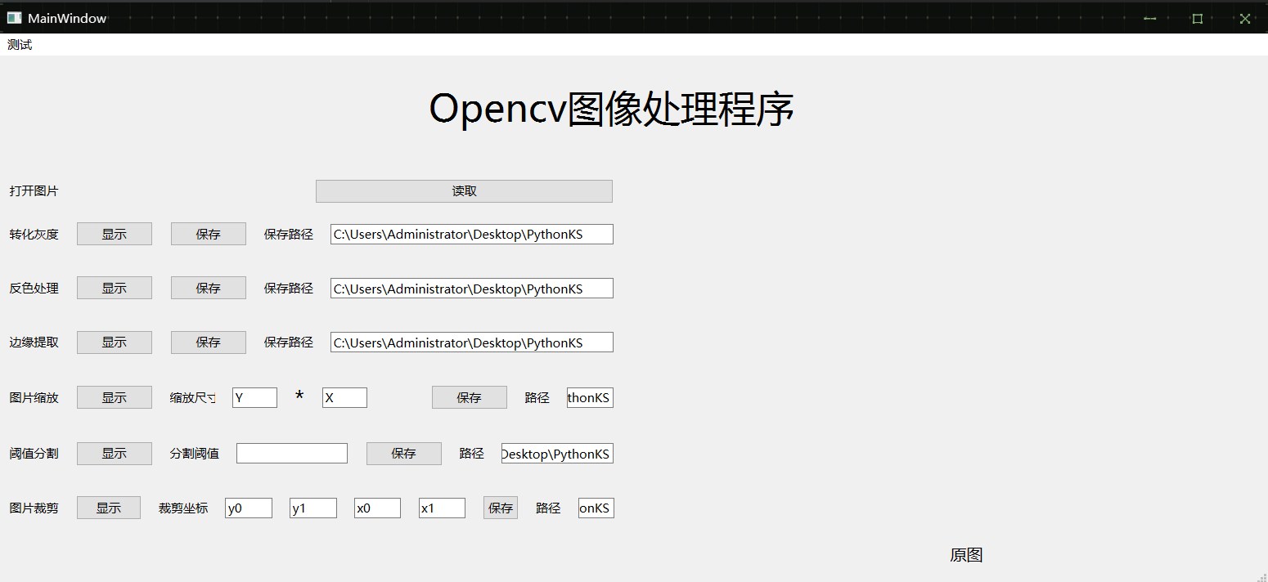

**图5.1主界面**

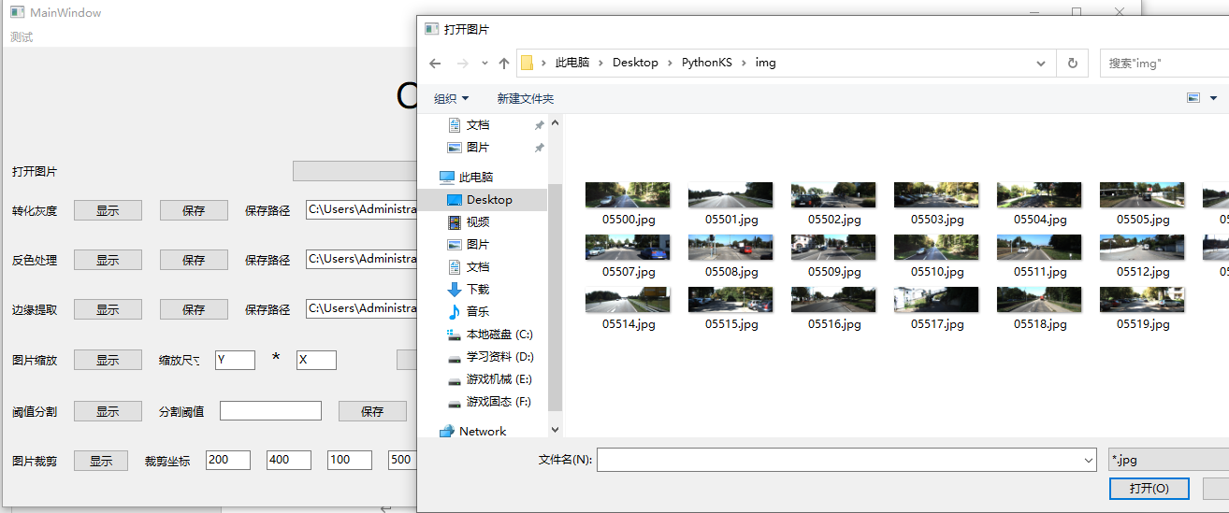

**图5.2读取文件夹图片**

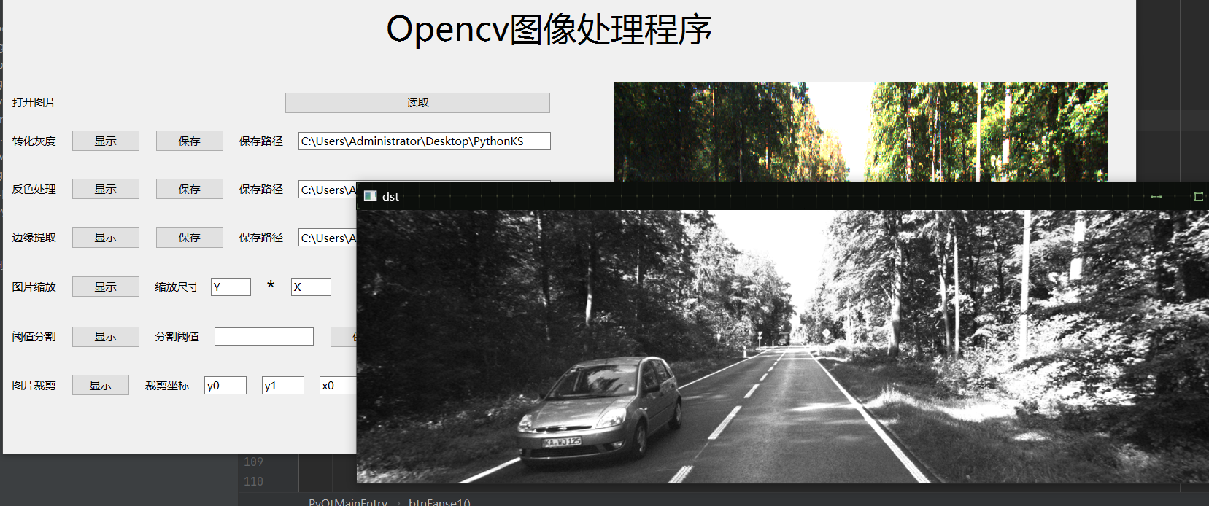

**图5.3转化灰度**

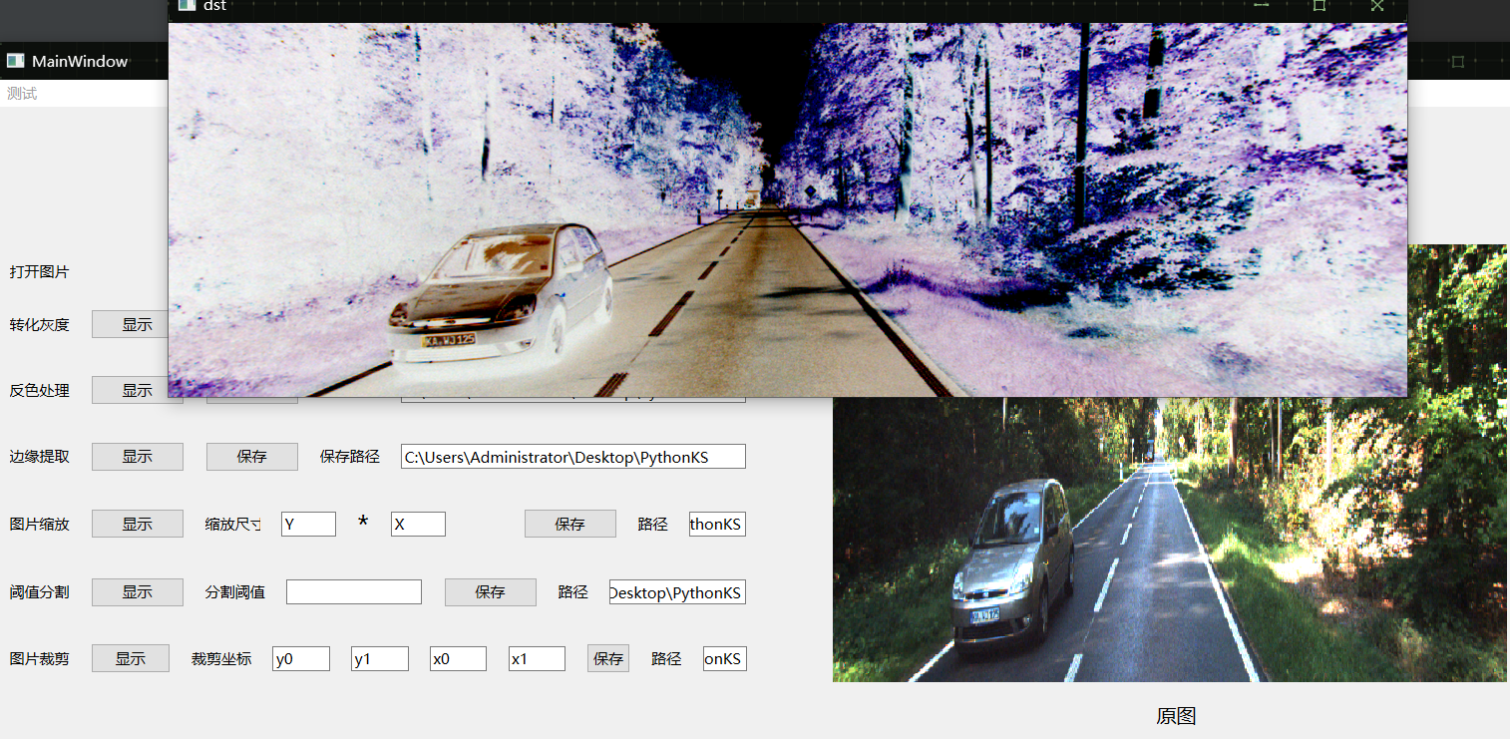

**图5.4反色处理**

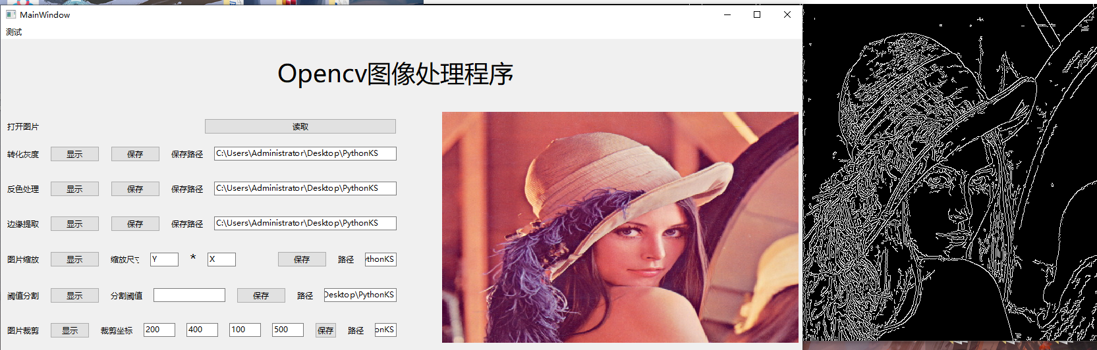

**图5.5边缘提取**

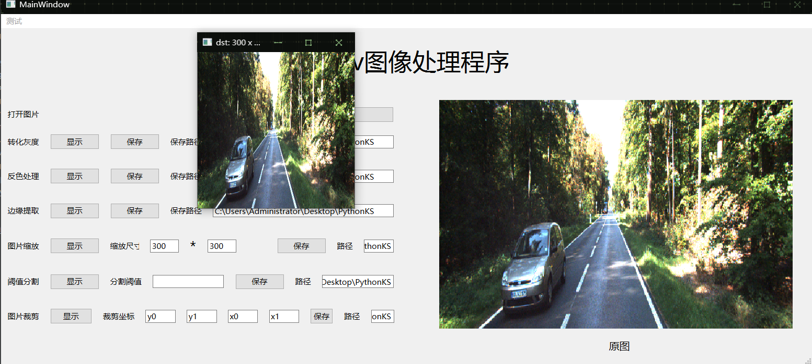

**图5.6图片缩放**

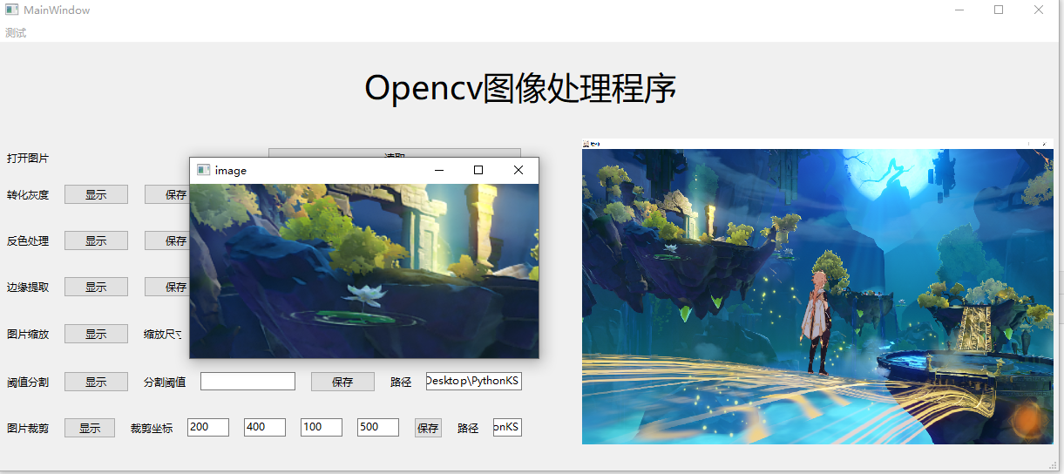

**图5.7图片裁剪**

## 6、源代码

Main.py

import sys

import cv2 as cv

import matplotlib.pyplot as plt

from PyQt6 import QtCore, QtGui, QtWidgets

from PyQt6.QtCore import *

from PyQt6.QtGui import *

from PyQt6.QtWidgets import QFileDialog, QMainWindow

import numpy as np

from mainForm import Ui_MainWindow

class PyQtMainEntry(QMainWindow, Ui_MainWindow):

def __init__(self):#初始化

super().__init__()

self.setupUi(self)

# def openimage(self):

# imgName, imgType = QFileDialog.getOpenFileName(self, "打开图片", "", "*.jpg;;*.png;;All Files(*)")

# jpg = QtGui.QPixmap(imgName).scaled(self.label.width(), self.label.height())

# self.label.setPixmap(jpg)

def btnReadImage_Clicked(self):#打开图片槽函数

filename, imgType = QFileDialog.getOpenFileName(self, "打开图片", "", "*.jpg;;*.png;;All Files(*)")

self.captured = cv.imread(str(filename))

self.captured1=cv.imread(str(filename),0)

jpg = QtGui.QPixmap(filename).scaled(self.label_b.width(), self.label_b.height())

self.label_b.setPixmap(jpg)

def btnReadImage_Clicked1(self):

'''

从本地读取图片

'''

# 打开文件选取对话框

filename, _ = QFileDialog.getOpenFileName(self, '打开图片')

if filename:

self.captured = cv.imread(str(filename))

# OpenCV图像以BGR通道存储，显示时需要从BGR转到RGB

self.captured = cv.cvtColor(self.captured, cv.COLOR_BGR2RGB)

rows, cols, channels = self.captured.shape

bytesPerLine = channels * cols

QImg = QImage(self.captured.data, cols, rows, bytesPerLine, QImage.Format_RGB888)

self.label_b.setPixmap(QPixmap.fromImage(QImg).scaled(

self.label_b.size(), Qt.KeepAspectRatio, Qt.SmoothTransformation))

def btnGray_Clicked(self):

'''

灰度化

'''

if not hasattr(self, "captured"):

return

self.gray=self.captured1

cv.imshow('dst',self.gray)

cv.waitKey(0)

cv.destroyAllWindows()

def btnSave1_Clicked(self):

if not hasattr(self, "captured"):

return

cv.imwrite('gray.jpg',self.gray)

print('保存成功')

def btnFanse(self):#反色图片 速度快

src = self.captured

if src is None:

return

dst = cv.bitwise_not(src) # 按位取反，白变黑，黑变白

self.fanse = dst

cv.imshow('dst', dst)

cv.waitKey()

def btnFanse1(self):#反色图片 速度慢

if not hasattr(self, "captured"):

return

cha = self.captured.shape

height, width, deep = cha

dst = np.zeros((height, width, 3), np.uint8)

for i in range(height): # 色彩反转

for j in range(width):

b, g, r = self.captured[i, j]

dst[i, j] = (255 - b, 255 - g, 255 - r)

self.fanse=dst

cv.imshow('dst', dst)

cv.waitKey()

def btnSave2_Clicked(self):

if not hasattr(self, "captured"):

return

cv.imwrite('fanse.jpg',self.fanse)

print('保存成功')

def btnByjc(self):

# Canny边缘检测

byjc=self.captured

v1 = cv.Canny(byjc, 80, 150, (3, 3))

v2 = cv.Canny(byjc, 50, 100, (5, 5))

# np.vstack():在竖直方向上堆叠

# np.hstack():在水平方向上平铺堆叠

self.ret = np.hstack((v1,v2))

cv.imshow('img',self.ret)

cv.waitKey(0)

cv.destroyAllWindows()

# Canny边缘检测

def btnByjc1(self):

src = self.captured

# if src is None:

# return

blurred = cv.GaussianBlur(src, (3, 3), 0)

gray = cv.cvtColor(blurred, cv.COLOR_BGR2GRAY)

grad_x = cv.Sobel(gray, cv.CV_16SC1, 1, 0)

grad_y = cv.Sobel(gray, cv.CV_16SC1, 0, 1)

dst = cv.Canny(grad_x, grad_y, 30, 150)

self.ret=dst

# dst = cv.Canny(gray, 50, 150)

def btnSave3_Clicked(self):

if not hasattr(self, "captured"):

return

cv.imwrite('byjc.jpg',self.ret)

print('保存成功')

def btnSuofang(self):#缩放图片

x,y=int(self.lineEdit.text()), int(self.lineEdit_5.text())

img=self.captured

dst = cv.resize(img, (x, y))

self.suofang=dst

cv.imshow("dst: %d x %d" % (dst.shape[0], dst.shape[1]), dst)

cv.waitKey(0)

cv.destroyAllWindows()

def btnSave4_Clicked(self):

if not hasattr(self, "captured"):

return

cv.imwrite('suofang.jpg',self.suofang)

print('保存成功')

def btnCut(self):

if not hasattr(self, "captured"):

return

img=self.captured

y0, y1 = int(self.lineEdit_y0.text()), int(self.lineEdit_y1.text())

x0, x1 = int(self.lineEdit_x0.text()), int(self.lineEdit_x1.text())

dst = img[y0:y1, x0:x1] # 裁剪坐标为[y0:y1, x0:x1]

self.cut=dst

cv.imshow('image', dst)

cv.waitKey(0)

def btnSave5_Clicked(self):

if not hasattr(self, "captured"):

return

cv.imwrite('cut.jpg',self.cut)

print('保存成功')

def btnThreshold_Clicked(self):

'''

Otsu自动阈值分割

'''

if not hasattr(self, "captured"):

return

_, self.cpatured = cv.threshold(

self.cpatured, 0, 255, cv.THRESH_BINARY + cv.THRESH_OTSU)

rows, columns = self.cpatured.shape

bytesPerLine = columns

# 阈值分割图也是单通道，也需要用Format_Indexed8

QImg = QImage(self.cpatured.data, columns, rows, bytesPerLine, QImage.Format_Indexed8)

self.labelResult.setPixmap(QPixmap.fromImage(QImg).scaled(

self.labelResult.size(), Qt.KeepAspectRatio, Qt.SmoothTransformation))

if __name__ == "__main__":

app = QtWidgets.QApplication(sys.argv)

window = PyQtMainEntry()

window.show()

sys.exit(app.exec())

mainForm.py

# Form implementation generated from reading ui file 'OPCVui.ui'

#

# Created by: PyQt6 UI code generator 6.1.0

#

# WARNING: Any manual changes made to this file will be lost when pyuic6 is

# run again. Do not edit this file unless you know what you are doing.

from PyQt6 import QtCore, QtGui, QtWidgets

class Ui_MainWindow(object):

def setupUi(self, MainWindow):

MainWindow.setObjectName("MainWindow")

MainWindow.resize(1242, 539)

self.centralwidget = QtWidgets.QWidget(MainWindow)

self.centralwidget.setObjectName("centralwidget")

self.label_b = QtWidgets.QLabel(self.centralwidget)

self.label_b.setGeometry(QtCore.QRect(670, 110, 541, 351))

font = QtGui.QFont()

font.setPointSize(24)

self.label_b.setFont(font)

self.label_b.setScaledContents(False)

self.label_b.setAlignment(QtCore.Qt.AlignmentFlag.AlignCenter)

self.label_b.setObjectName("label_b")

self.label_3 = QtWidgets.QLabel(self.centralwidget)

self.label_3.setGeometry(QtCore.QRect(930, 480, 55, 16))

font = QtGui.QFont()

font.setPointSize(12)

self.label_3.setFont(font)

self.label_3.setObjectName("label_3")

self.label_2 = QtWidgets.QLabel(self.centralwidget)

self.label_2.setGeometry(QtCore.QRect(420, 20, 361, 61))

font = QtGui.QFont()

font.setPointSize(28)

self.label_2.setFont(font)

self.label_2.setObjectName("label_2")

self.layoutWidget = QtWidgets.QWidget(self.centralwidget)

self.layoutWidget.setGeometry(QtCore.QRect(10, 120, 591, 351))

self.layoutWidget.setObjectName("layoutWidget")

self.verticalLayout_2 = QtWidgets.QVBoxLayout(self.layoutWidget)

self.verticalLayout_2.setContentsMargins(0, 0, 0, 0)

self.verticalLayout_2.setObjectName("verticalLayout_2")

self.horizontalLayout_28 = QtWidgets.QHBoxLayout()

self.horizontalLayout_28.setObjectName("horizontalLayout_28")

self.label_22 = QtWidgets.QLabel(self.layoutWidget)

self.label_22.setObjectName("label_22")

self.horizontalLayout_28.addWidget(self.label_22)

self.pushButton_3 = QtWidgets.QPushButton(self.layoutWidget)

self.pushButton_3.setObjectName("pushButton_3")

self.horizontalLayout_28.addWidget(self.pushButton_3)

self.verticalLayout_2.addLayout(self.horizontalLayout_28)

self.verticalLayout = QtWidgets.QVBoxLayout()

self.verticalLayout.setSpacing(17)

self.verticalLayout.setObjectName("verticalLayout")

self.horizontalLayout_2 = QtWidgets.QHBoxLayout()

self.horizontalLayout_2.setObjectName("horizontalLayout_2")

self.verticalLayout.addLayout(self.horizontalLayout_2)

self.horizontalLayout = QtWidgets.QHBoxLayout()

self.horizontalLayout.setObjectName("horizontalLayout")

self.verticalLayout.addLayout(self.horizontalLayout)

self.horizontalLayout_16 = QtWidgets.QHBoxLayout()

self.horizontalLayout_16.setObjectName("horizontalLayout_16")

self.horizontalLayout_3 = QtWidgets.QHBoxLayout()

self.horizontalLayout_3.setObjectName("horizontalLayout_3")

self.label_4 = QtWidgets.QLabel(self.layoutWidget)

self.label_4.setObjectName("label_4")

self.horizontalLayout_3.addWidget(self.label_4)

self.pushButton_2 = QtWidgets.QPushButton(self.layoutWidget)

self.pushButton_2.setObjectName("pushButton_2")

self.horizontalLayout_3.addWidget(self.pushButton_2)

self.horizontalLayout_16.addLayout(self.horizontalLayout_3)

self.horizontalLayout_5 = QtWidgets.QHBoxLayout()

self.horizontalLayout_5.setObjectName("horizontalLayout_5")

self.pushButton = QtWidgets.QPushButton(self.layoutWidget)

self.pushButton.setObjectName("pushButton")

self.horizontalLayout_5.addWidget(self.pushButton)

self.label_7 = QtWidgets.QLabel(self.layoutWidget)

self.label_7.setObjectName("label_7")

self.horizontalLayout_5.addWidget(self.label_7)

self.lineEdit_2 = QtWidgets.QLineEdit(self.layoutWidget)

self.lineEdit_2.setObjectName("lineEdit_2")

self.horizontalLayout_5.addWidget(self.lineEdit_2)

self.horizontalLayout_16.addLayout(self.horizontalLayout_5)

self.verticalLayout.addLayout(self.horizontalLayout_16)

self.horizontalLayout_17 = QtWidgets.QHBoxLayout()

self.horizontalLayout_17.setObjectName("horizontalLayout_17")

self.horizontalLayout_4 = QtWidgets.QHBoxLayout()

self.horizontalLayout_4.setObjectName("horizontalLayout_4")

self.label_5 = QtWidgets.QLabel(self.layoutWidget)

self.label_5.setObjectName("label_5")

self.horizontalLayout_4.addWidget(self.label_5)

self.pushButton_4 = QtWidgets.QPushButton(self.layoutWidget)

self.pushButton_4.setObjectName("pushButton_4")

self.horizontalLayout_4.addWidget(self.pushButton_4)

self.horizontalLayout_17.addLayout(self.horizontalLayout_4)

self.horizontalLayout_6 = QtWidgets.QHBoxLayout()

self.horizontalLayout_6.setObjectName("horizontalLayout_6")

self.pushButton_9 = QtWidgets.QPushButton(self.layoutWidget)

self.pushButton_9.setObjectName("pushButton_9")

self.horizontalLayout_6.addWidget(self.pushButton_9)

self.label_8 = QtWidgets.QLabel(self.layoutWidget)

self.label_8.setObjectName("label_8")

self.horizontalLayout_6.addWidget(self.label_8)

self.lineEdit_3 = QtWidgets.QLineEdit(self.layoutWidget)

self.lineEdit_3.setObjectName("lineEdit_3")

self.horizontalLayout_6.addWidget(self.lineEdit_3)

self.horizontalLayout_17.addLayout(self.horizontalLayout_6)

self.verticalLayout.addLayout(self.horizontalLayout_17)

self.horizontalLayout_18 = QtWidgets.QHBoxLayout()

self.horizontalLayout_18.setObjectName("horizontalLayout_18")

self.horizontalLayout_7 = QtWidgets.QHBoxLayout()

self.horizontalLayout_7.setObjectName("horizontalLayout_7")

self.label_6 = QtWidgets.QLabel(self.layoutWidget)

self.label_6.setObjectName("label_6")

self.horizontalLayout_7.addWidget(self.label_6)

self.pushButton_5 = QtWidgets.QPushButton(self.layoutWidget)

self.pushButton_5.setObjectName("pushButton_5")

self.horizontalLayout_7.addWidget(self.pushButton_5)

self.horizontalLayout_18.addLayout(self.horizontalLayout_7)

self.horizontalLayout_8 = QtWidgets.QHBoxLayout()

self.horizontalLayout_8.setObjectName("horizontalLayout_8")

self.pushButton_10 = QtWidgets.QPushButton(self.layoutWidget)

self.pushButton_10.setObjectName("pushButton_10")

self.horizontalLayout_8.addWidget(self.pushButton_10)

self.label_9 = QtWidgets.QLabel(self.layoutWidget)

self.label_9.setObjectName("label_9")

self.horizontalLayout_8.addWidget(self.label_9)

self.lineEdit_4 = QtWidgets.QLineEdit(self.layoutWidget)

self.lineEdit_4.setObjectName("lineEdit_4")

self.horizontalLayout_8.addWidget(self.lineEdit_4)

self.horizontalLayout_18.addLayout(self.horizontalLayout_8)

self.verticalLayout.addLayout(self.horizontalLayout_18)

self.horizontalLayout_21 = QtWidgets.QHBoxLayout()

self.horizontalLayout_21.setObjectName("horizontalLayout_21")

self.horizontalLayout_9 = QtWidgets.QHBoxLayout()

self.horizontalLayout_9.setObjectName("horizontalLayout_9")

self.label_10 = QtWidgets.QLabel(self.layoutWidget)

self.label_10.setObjectName("label_10")

self.horizontalLayout_9.addWidget(self.label_10)

self.pushButton_6 = QtWidgets.QPushButton(self.layoutWidget)

self.pushButton_6.setObjectName("pushButton_6")

self.horizontalLayout_9.addWidget(self.pushButton_6)

self.horizontalLayout_21.addLayout(self.horizontalLayout_9)

self.horizontalLayout_10 = QtWidgets.QHBoxLayout()

self.horizontalLayout_10.setObjectName("horizontalLayout_10")

self.label_11 = QtWidgets.QLabel(self.layoutWidget)

self.label_11.setObjectName("label_11")

self.horizontalLayout_10.addWidget(self.label_11)

self.lineEdit = QtWidgets.QLineEdit(self.layoutWidget)

self.lineEdit.setObjectName("lineEdit")

self.horizontalLayout_10.addWidget(self.lineEdit)

self.label_18 = QtWidgets.QLabel(self.layoutWidget)

font = QtGui.QFont()

font.setPointSize(16)

self.label_18.setFont(font)

self.label_18.setObjectName("label_18")

self.horizontalLayout_10.addWidget(self.label_18)

self.lineEdit_5 = QtWidgets.QLineEdit(self.layoutWidget)

self.lineEdit_5.setObjectName("lineEdit_5")

self.horizontalLayout_10.addWidget(self.lineEdit_5)

self.label = QtWidgets.QLabel(self.layoutWidget)

self.label.setText("")

self.label.setObjectName("label")

self.horizontalLayout_10.addWidget(self.label)

self.label_17 = QtWidgets.QLabel(self.layoutWidget)

self.label_17.setText("")

self.label_17.setObjectName("label_17")

self.horizontalLayout_10.addWidget(self.label_17)

self.horizontalLayout_21.addLayout(self.horizontalLayout_10)

self.horizontalLayout_11 = QtWidgets.QHBoxLayout()

self.horizontalLayout_11.setObjectName("horizontalLayout_11")

self.pushButton_11 = QtWidgets.QPushButton(self.layoutWidget)

self.pushButton_11.setObjectName("pushButton_11")

self.horizontalLayout_11.addWidget(self.pushButton_11)

self.label_12 = QtWidgets.QLabel(self.layoutWidget)

self.label_12.setObjectName("label_12")

self.horizontalLayout_11.addWidget(self.label_12)

self.lineEdit_6 = QtWidgets.QLineEdit(self.layoutWidget)

self.lineEdit_6.setObjectName("lineEdit_6")

self.horizontalLayout_11.addWidget(self.lineEdit_6)

self.horizontalLayout_21.addLayout(self.horizontalLayout_11)

self.verticalLayout.addLayout(self.horizontalLayout_21)

self.horizontalLayout_26 = QtWidgets.QHBoxLayout()

self.horizontalLayout_26.setObjectName("horizontalLayout_26")

self.horizontalLayout_14 = QtWidgets.QHBoxLayout()

self.horizontalLayout_14.setObjectName("horizontalLayout_14")

self.label_15 = QtWidgets.QLabel(self.layoutWidget)

self.label_15.setObjectName("label_15")

self.horizontalLayout_14.addWidget(self.label_15)

self.pushButton_8 = QtWidgets.QPushButton(self.layoutWidget)

self.pushButton_8.setObjectName("pushButton_8")

self.horizontalLayout_14.addWidget(self.pushButton_8)

self.horizontalLayout_26.addLayout(self.horizontalLayout_14)

self.horizontalLayout_15 = QtWidgets.QHBoxLayout()

self.horizontalLayout_15.setObjectName("horizontalLayout_15")

self.label_16 = QtWidgets.QLabel(self.layoutWidget)

self.label_16.setObjectName("label_16")

self.horizontalLayout_15.addWidget(self.label_16)

self.lineEdit_8 = QtWidgets.QLineEdit(self.layoutWidget)

self.lineEdit_8.setObjectName("lineEdit_8")

self.horizontalLayout_15.addWidget(self.lineEdit_8)

self.horizontalLayout_26.addLayout(self.horizontalLayout_15)

self.horizontalLayout_19 = QtWidgets.QHBoxLayout()

self.horizontalLayout_19.setObjectName("horizontalLayout_19")

self.pushButton_13 = QtWidgets.QPushButton(self.layoutWidget)

self.pushButton_13.setObjectName("pushButton_13")

self.horizontalLayout_19.addWidget(self.pushButton_13)

self.label_20 = QtWidgets.QLabel(self.layoutWidget)

self.label_20.setObjectName("label_20")

self.horizontalLayout_19.addWidget(self.label_20)

self.lineEdit_11 = QtWidgets.QLineEdit(self.layoutWidget)

self.lineEdit_11.setObjectName("lineEdit_11")

self.horizontalLayout_19.addWidget(self.lineEdit_11)

self.horizontalLayout_26.addLayout(self.horizontalLayout_19)

self.verticalLayout.addLayout(self.horizontalLayout_26)

self.horizontalLayout_27 = QtWidgets.QHBoxLayout()

self.horizontalLayout_27.setObjectName("horizontalLayout_27")

self.horizontalLayout_12 = QtWidgets.QHBoxLayout()

self.horizontalLayout_12.setObjectName("horizontalLayout_12")

self.label_13 = QtWidgets.QLabel(self.layoutWidget)

self.label_13.setObjectName("label_13")

self.horizontalLayout_12.addWidget(self.label_13)

self.pushButton_7 = QtWidgets.QPushButton(self.layoutWidget)

self.pushButton_7.setObjectName("pushButton_7")

self.horizontalLayout_12.addWidget(self.pushButton_7)

self.horizontalLayout_27.addLayout(self.horizontalLayout_12)

self.horizontalLayout_13 = QtWidgets.QHBoxLayout()

self.horizontalLayout_13.setObjectName("horizontalLayout_13")

self.label_14 = QtWidgets.QLabel(self.layoutWidget)

self.label_14.setObjectName("label_14")

self.horizontalLayout_13.addWidget(self.label_14)

self.lineEdit_y0 = QtWidgets.QLineEdit(self.layoutWidget)

self.lineEdit_y0.setObjectName("lineEdit_y0")

self.horizontalLayout_13.addWidget(self.lineEdit_y0)

self.horizontalLayout_27.addLayout(self.horizontalLayout_13)

self.lineEdit_y1 = QtWidgets.QLineEdit(self.layoutWidget)

self.lineEdit_y1.setObjectName("lineEdit_y1")

self.horizontalLayout_27.addWidget(self.lineEdit_y1)

self.lineEdit_x0 = QtWidgets.QLineEdit(self.layoutWidget)

self.lineEdit_x0.setObjectName("lineEdit_x0")

self.horizontalLayout_27.addWidget(self.lineEdit_x0)

self.lineEdit_x1 = QtWidgets.QLineEdit(self.layoutWidget)

self.lineEdit_x1.setObjectName("lineEdit_x1")

self.horizontalLayout_27.addWidget(self.lineEdit_x1)

self.horizontalLayout_20 = QtWidgets.QHBoxLayout()

self.horizontalLayout_20.setObjectName("horizontalLayout_20")

self.pushButton_12 = QtWidgets.QPushButton(self.layoutWidget)

self.pushButton_12.setObjectName("pushButton_12")

self.horizontalLayout_20.addWidget(self.pushButton_12)

self.label_21 = QtWidgets.QLabel(self.layoutWidget)

self.label_21.setObjectName("label_21")

self.horizontalLayout_20.addWidget(self.label_21)

self.lineEdit_12 = QtWidgets.QLineEdit(self.layoutWidget)

self.lineEdit_12.setObjectName("lineEdit_12")

self.horizontalLayout_20.addWidget(self.lineEdit_12)

self.horizontalLayout_27.addLayout(self.horizontalLayout_20)

self.verticalLayout.addLayout(self.horizontalLayout_27)

self.verticalLayout_2.addLayout(self.verticalLayout)

MainWindow.setCentralWidget(self.centralwidget)

self.menubar = QtWidgets.QMenuBar(MainWindow)

self.menubar.setGeometry(QtCore.QRect(0, 0, 1242, 22))

self.menubar.setObjectName("menubar")

self.menu = QtWidgets.QMenu(self.menubar)

self.menu.setObjectName("menu")

MainWindow.setMenuBar(self.menubar)

self.statusbar = QtWidgets.QStatusBar(MainWindow)

self.statusbar.setObjectName("statusbar")

MainWindow.setStatusBar(self.statusbar)

self.menubar.addAction(self.menu.menuAction())

self.retranslateUi(MainWindow)

self.pushButton_2.clicked.connect(MainWindow.btnGray_Clicked)

self.pushButton_3.clicked.connect(MainWindow.btnReadImage_Clicked)

self.pushButton.clicked.connect(MainWindow.btnSave1_Clicked)

self.pushButton_4.clicked.connect(MainWindow.btnFanse)

self.pushButton_9.clicked.connect(MainWindow.btnSave2_Clicked)

self.pushButton_5.clicked.connect(MainWindow.btnByjc)

self.pushButton_10.clicked.connect(MainWindow.btnSave3_Clicked)

self.pushButton_6.clicked.connect(MainWindow.btnSuofang)

self.pushButton_11.clicked.connect(MainWindow.btnSave4_Clicked)

self.pushButton_12.clicked.connect(MainWindow.btnSave5_Clicked)

self.pushButton_7.clicked.connect(MainWindow.btnCut)

QtCore.QMetaObject.connectSlotsByName(MainWindow)

def retranslateUi(self, MainWindow):

_translate = QtCore.QCoreApplication.translate

MainWindow.setWindowTitle(_translate("MainWindow", "MainWindow"))

self.label_b.setText(_translate("MainWindow","<html><head/><body><p><br/></p></body><ml>"))

self.label_3.setText(_translate("MainWindow", "原图"))

self.label_2.setText(_translate("MainWindow", "Opencv图像处理程序"))

self.label_22.setText(_translate("MainWindow", "打开图片"))

self.pushButton_3.setText(_translate("MainWindow", "读取"))

self.label_4.setText(_translate("MainWindow", "转化灰度"))

self.pushButton_2.setText(_translate("MainWindow", "显示"))

self.pushButton.setText(_translate("MainWindow", "保存"))

self.label_7.setText(_translate("MainWindow", "保存路径"))

self.lineEdit_2.setText(_translate("MainWindow", "C:\\Users\\Administrator\\Desktop\\PythonKS"))

self.label_5.setText(_translate("MainWindow", "反色处理"))

self.pushButton_4.setText(_translate("MainWindow", "显示"))

self.pushButton_9.setText(_translate("MainWindow", "保存"))

self.label_8.setText(_translate("MainWindow", "保存路径"))

self.lineEdit_3.setText(_translate("MainWindow", "C:\\Users\\Administrator\\Desktop\\PythonKS"))

self.label_6.setText(_translate("MainWindow", "边缘提取"))

self.pushButton_5.setText(_translate("MainWindow", "显示"))

self.pushButton_10.setText(_translate("MainWindow", "保存"))

self.label_9.setText(_translate("MainWindow", "保存路径"))

self.lineEdit_4.setText(_translate("MainWindow", "C:\\Users\\Administrator\\Desktop\\PythonKS"))

self.label_10.setText(_translate("MainWindow", "图片缩放"))

self.pushButton_6.setText(_translate("MainWindow", "显示"))

self.label_11.setText(_translate("MainWindow", "缩放尺寸"))

self.lineEdit.setText(_translate("MainWindow", "Y"))

self.label_18.setText(_translate("MainWindow", "*"))

self.lineEdit_5.setText(_translate("MainWindow", "X"))

self.pushButton_11.setText(_translate("MainWindow", "保存"))

self.label_12.setText(_translate("MainWindow", "路径"))

self.lineEdit_6.setText(_translate("MainWindow", "C:\\Users\\Administrator\\Desktop\\PythonKS"))

self.label_15.setText(_translate("MainWindow", "阈值分割"))

self.pushButton_8.setText(_translate("MainWindow", "显示"))

self.label_16.setText(_translate("MainWindow", "分割阈值"))

self.pushButton_13.setText(_translate("MainWindow", "保存"))

self.label_20.setText(_translate("MainWindow", "路径"))

self.lineEdit_11.setText(_translate("MainWindow", "C:\\Users\\Administrator\\Desktop\\PythonKS"))

self.label_13.setText(_translate("MainWindow", "图片裁剪"))

self.pushButton_7.setText(_translate("MainWindow", "显示"))

self.label_14.setText(_translate("MainWindow", "裁剪坐标"))

self.lineEdit_y0.setText(_translate("MainWindow", "y0"))

self.lineEdit_y1.setText(_translate("MainWindow", "y1"))

self.lineEdit_x0.setText(_translate("MainWindow", "x0"))

self.lineEdit_x1.setText(_translate("MainWindow", "x1"))

self.pushButton_12.setText(_translate("MainWindow", "保存"))

self.label_21.setText(_translate("MainWindow", "路径"))

self.lineEdit_12.setText(_translate("MainWindow", "C:\\Users\\Administrator\\Desktop\\PythonKS"))

self.menu.setTitle(_translate("MainWindow", "测试"))

## 7、总结

## 8、参考文献

1.埃里克.《Python编程：从入门到实践》，人民邮电出版社，2021，教材。

2.董付国.《Python程序设计基础与应用》，机械工业出版社，2018，参考书目。

3.John Zelle.《Python程序设计》，人民邮电出版社，2018，参考书目

4.Cay S.Horstmann.《Python程序设计》，机械工业出版社，2018，参考书目。